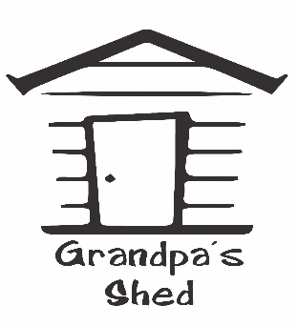
TERMS AND CONDITIONS
General
This website is owned and operated by Grandpas Shed.
If you wish to contact us please email: ian@grandpasshed.kiwi
Disclaimer
This online service provides general information about Grandpas Shed and the products and/or services it offers. The information contained in this website has been prepared solely for the purpose of providing information about Grandpas Shed and the services and products they offer.
Grandpas Sheds reserves the right to change, delete or move any of the material on this website at anytime without notice.
To the extent permitted by New Zealand law, Grandpas Shed makes no warranties in relation to the merchantability, fitness for purpose, freedom from computer virus, accuracy or availability of this website or any other website.

Changes to Terms and Conditions
We may change these terms and conditions at any time. Each time you use grandpasshed.kiwi you are agreeing to the terms and conditions applicable at that time. We provide a link to these Terms & Conditions at the bottom of every page of the website.

Jurisdiction
The laws of New Zealand apply to these terms and conditions. Any dispute arising in relation to these terms and conditions will be resolved in accordance with New Zealand law.

Pricing
All prices are stated in New Zealand dollars (NZ$) and include GST (15% sales tax).
All prices are correct at time of publication; however we reserve the right to alter prices for any reason.
We reserve the right to correct all errors and omissions (whether clerical, computational or otherwise) in any advertising, quotation, invoice or acknowledgement.
We will not be held responsible or liable for any inaccurate, incomplete, or out-of-date information on our website.
If you purchase a product for an incorrect price or with incorrect information, we reserve the right to cancel your order (regardless of whether you have made payment). Should this occur, we will refund the amount paid by you in relation to the cancelled order.

Special Offers
Special offers and deals on this site are only valid for so long as they are displayed, unless expressly stated otherwise.

Consumers Guarantees Act
If the products are subject to the New Zealand Consumer Guarantees Act 1993 ("CGA"), you may have statutory rights and remedies which are not excluded nor limited by the above provisions unless you are acquiring the products for business purposes, in which case all of the above exclusions and limitations will apply and the CGA will not apply.

Privacy Policy
At Grandpas Shed, we collect information about you through our website in an effort to improve your shopping experience, as well as communicate with you about our products, services and promotions. We do not sell your personal information to third parties.

Cancelling Orders by Grandpas Shed
Grandpas Shed reserves the right to cancel orders for any reason, or to cancel the purchase agreement after order confirmation, including (without limitation) where Grandpas Shed believes the order to be fraudulent or constitute a mis-use of a promotional or marketing activity, or where an error has occurred including, but not limited to, errors relating to pricing. If we do cancel your order or purchase agreement, we accept no liability for any resulting damages or costs suffered by you, however we will refund the purchase price to you (where it has already been paid).

Intellectual Property and Copyright
Grandpas Shed, its suppliers, or third party providers, own all copyright and other intellectual property in this site. The Grandpas Shed name and logo may not be copied, reproduced or used for any commercial purpose without our prior written approval.

Changes to this Agreement
Grandpas Shed reserves the right to alter, modify or update these terms of use. These terms apply to your order. We may change our terms and conditions at any time, so please do not assume that the same terms will apply to future orders.

